**College of Computer Science and Engineering**

**Department of Computer Science and Artificial Intelligence**

**CCAI-321: Artificial Neural Networks**

**Lab#1 Introduction to Transfer Functions using Python**

# PLO = S1 - AI

**Marks:**

|  |  |  |  |  |  |  |
| --- | --- | --- | --- | --- | --- | --- |
|  | **Q1** | **Q 2** | **Q 3** | **Q 4** | **Q 5** | **Total** |
| **Allocated** | **2** | **2** | **2** | **2** | **2** | **10** |
| **Obtained** | **2** | **2** | **2** | **2** | **2** | **10** |
|  |  |  |  |  |  |  |
| **Allocated** |  |  |  |  |  |  |
| **Marks** |  |  |  |  |  |  |

**Weighted Marks:**

|  |  |  |  |
| --- | --- | --- | --- |
| **Allocated** |  |  |  |
| **Obtained** |  |  |  |

# Objectives

* Understand why python is the top programming language for machine learning
* Implement various Transfer Functions (Activation Functions) in python

# Lab Tool(s)

[Download Python | Python.org](https://www.python.org/downloads/)

[Anaconda | Individual Edition](https://www.anaconda.com/products/individual)

# Lab Deliverables

Submit a pdf document on Blackboard containing your solution to the lab assessment at the end of this document.

# Why Python is the top programming language for ML/NN?

Top programming languages for AI / Machine Learning / Neural Networks

|  |  |  |
| --- | --- | --- |
|  | Language | Notes |
| 1 | Python | Simple + many libraries to support ML |
| 2 | R | Useful for statistical purposes + has packages that support ML |

## What makes python the best programming language for ML?

AI projects differ from traditional software projects. The differences lie in the technology stack, the skills required for an AI-based project, and the necessity of deep research. To implement your AI aspirations, you should use a **programming language that is stable, flexible, and has tools available.** Python offers all of this, which is why we see lots of Python AI projects today.

From development to deployment and maintenance, **Python helps developers be productive** and confident about the software they’re building. Benefits that make Python the best fit for machine learning and AI-based projects include **simplicity and consistency, access to great libraries and frameworks for AI and machine learning (ML), flexibility, platform independence, and a wide community**. These add to the overall popularity of the language.

### Simple and consistent

Python offers **concise and readable code**. While complex algorithms and versatile workflows stand behind machine learning and AI, Python’s simplicity allows developers to write reliable systems. Developers get to put all their effort into solving an ML problem instead of focusing on the technical nuances of the language.

Additionally, Python is appealing to many developers as it’s **easy to learn**. Python code is understandable by humans, which makes it easier to build models for machine learning.

Many programmers say that Python is more intuitive than other programming languages. Others point out the many frameworks, libraries, and extensions that simplify the implementation of different functionalities. It’s generally accepted that Python is suitable for collaborative implementation when multiple developers are involved. Since Python is a general-purpose language, it can do a set of complex machine learning tasks and enable you to build prototypes quickly that allow you to test your product for machine learning purposes.

### Extensive selection of libraries and frameworks

Implementing AI and ML algorithms can be tricky and requires a lot of time. It’s vital to have a well-structured and well-tested environment to enable developers to come up with the best coding solutions.

To reduce development time, programmers turn to a number of Python frameworks and libraries. A software library is pre-written code that developers use to solve common programming tasks. Python, with its rich technology stack, has an extensive set of libraries for artificial intelligence and machine learning. Here are some of them:

* Keras, TensorFlow, and Scikit-learn for machine learning
* NumPy for high-performance scientific computing and data analysis
* SciPy for advanced computing
* Pandas for general-purpose data anal
* Pandas for general-purpose data analysis
* Seaborn for data visualization

Scikit-learn features various classification, regression, and clustering algorithms, including support vector machines, random forests, gradient boosting, k-means, and DBSCAN, and is designed to work with the Python numerical and scientific libraries NumPy and SciPy.

With these solutions, you can develop your product faster. Your development team won’t have to reinvent the wheel and can use an existing library to implement necessary features.

What is Python good for?

Here’s a table of сommon AI use cases and technologies that are best suited for them. We recommend using these:

|  |  |
| --- | --- |
| Data analysis and visualization | NumPy, SciPy, Pandas, Seaborn |
| Machine learning | TensorFlow, Keras, Scikit-learn |
| Computer vision | OpenCV |
| Natural language processing | NLTK, spaCy |

### Platform independence

Platform independence refers to a programming language or framework allowing developers to implement things on one machine and use them on another machine without any (or with only minimal) changes. One key to Python’s popularity is that it’s a platform independent language. Python is supported by many platforms including Linux, Windows, and macOS. Python code can be used to create standalone executable programs for most common operating systems, which means that Python software can be easily distributed and used on those operating systems without a Python interpreter.

What’s more, developers usually use services such as Google or Amazon for their computing needs. However, you can often find companies and data scientists who use their own machines with powerful Graphics Processing Units (GPUs) to train their ML models. And the fact that Python is platform independent makes this training a lot cheaper and easier.

### Great community and popularity

In the Developer Survey 2018 by Stack Overflow, Python was among the top 10 most popular programming languages, which ultimately means that you can find and ф a development company with the necessary skill set to build your AI-based project.

If you look closely at the image below, you’ll see that Python is the language that people Google more than any other.

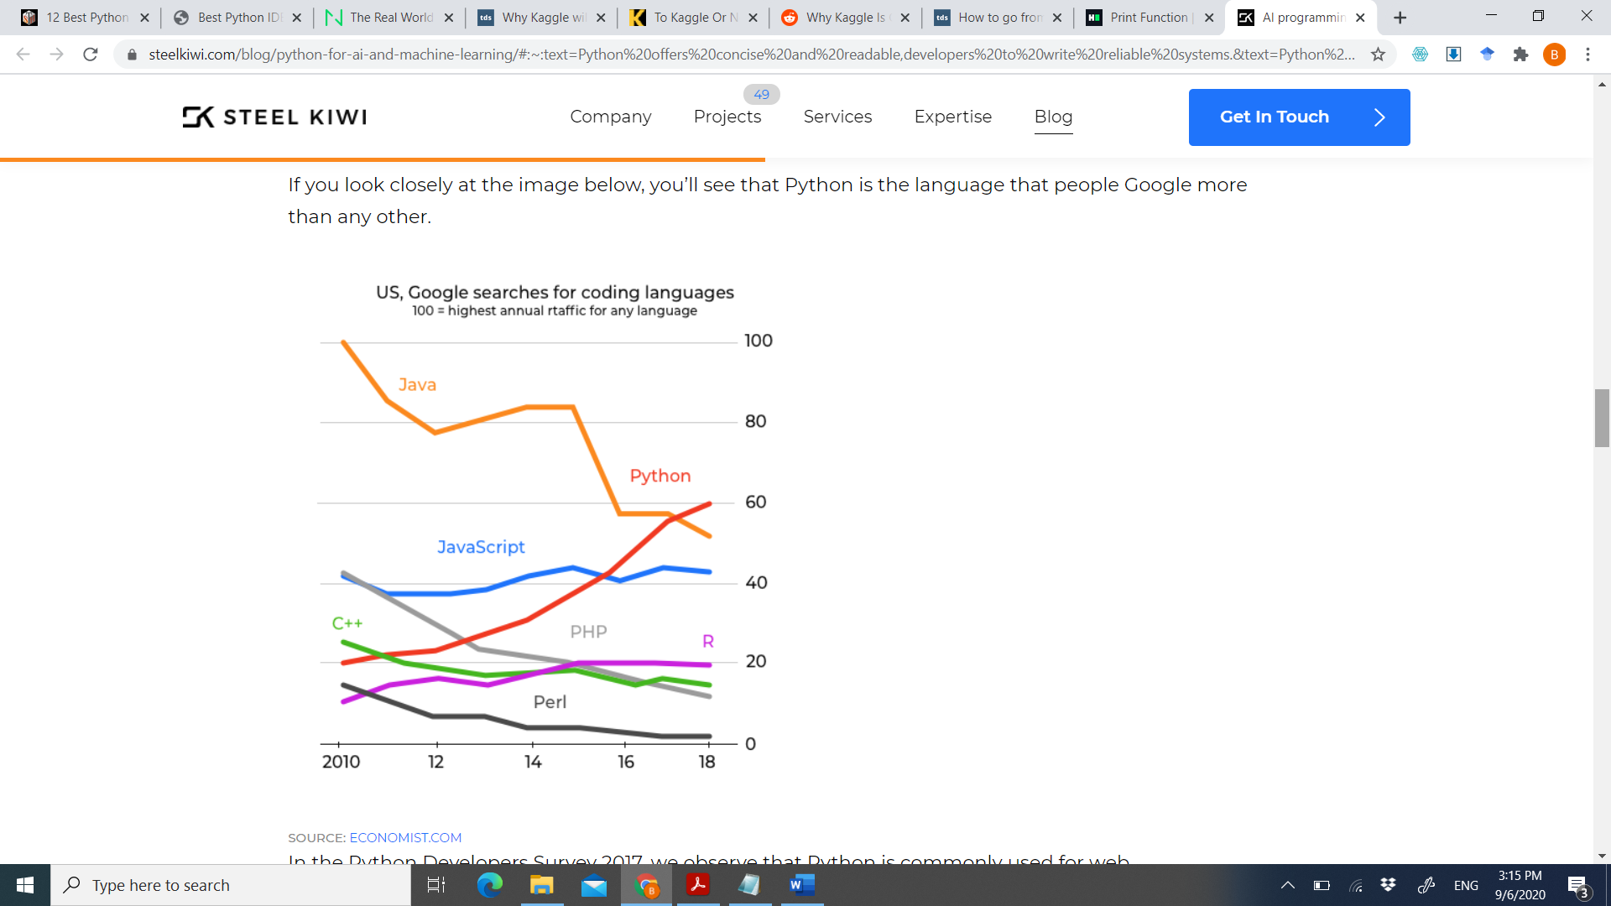

# Lab Assessment

A simple Artificial Neuron has a summer and an activation (transfer) function connected in series as shown in the figure below. For a single input neuron, shown in the figure, there is a single input ‘p’ weighted by a weight ‘w’ added to a bias value ‘b’. The result of summing these quantities is given as ‘n=wp+b’. This value is passed to a transfer function ‘f’ to obtain a output ‘a’ of the neuron in a predefined desired range.

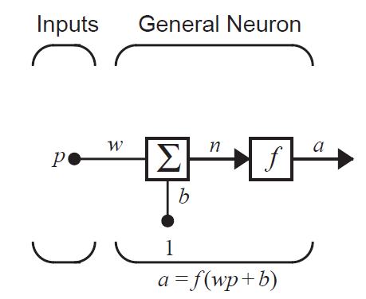

Transfer functions may be linear or non-linear, clipped or unclipped, continuous or not. Thus, different transfer functions have been proposed over the years to obtain desired benefits from them. A few transfer functions are presented below for reference.

|  |  |  |  |
| --- | --- | --- | --- |
| Name | Description | Shape | Comments |
| Hardlimit | $$hardlim\left(n\right)=\left\{\begin{matrix}0 for n<0 \\ 1 else\end{matrix}\right.$$ |  | The function is not continuous as it jumps from zero to one. |
| Linear | $$purelin\left(n\right)=n$$ |  | The output of the function keeps on increasing and never clips to any value |
| Logsigmoid | $$logsig(n)=\frac{1}{(1+e^{-n})}$$ |  | Continuous and clipped between 0 and 1. |
| Hyperbolic Tangent | $$htan(n)=\frac{e^{n}-e^{-n}}{e^{n}+e^{-n}}$$ |  | Continuous and clipped between -0.5 and 0.5 |
| Positive Linear | $$poslin\left(n\right)=\left\{\begin{matrix}0 for n<0 \\ n else\end{matrix}\right.$$ |  | Continuous yet clipped at 0 and linear for +ive values  a = max(n,0) |

These transfer functions were discussed in class. You are required to implement the functionality of each of these transfer functions and draw the output of the transfer function.

**Q1. Plot the output of the logsigmoid function for n=-5 to 5 [2 marks]**

**Q2. Plot the output of the hardlim transfer function for n=-5 to 5 [2 marks]**

**Q3. Plot the output of the linear transfer function for n=-5 to 5 [2 marks]**

**Q4. Plot the output of the than transfer function for n=-5 to 5 [2 marks]**

**Q5. Plot the output of the positive linear transfer function for n=-5 to 5 [2 marks]**

# References:

[Top 5 programming languages for AI](https://www.geeksforgeeks.org/top-5-best-programming-languages-for-artificial-intelligence-field/),

[Python for AI and machine learning](https://steelkiwi.com/blog/python-for-ai-and-machine-learning/#:~:text=Python%20offers%20concise%20and%20readable,developers%20to%20write%20reliable%20systems.&text=Python%20code%20is%20understandable%20by,build%20models%20for%20machine%20learning.)